Muhammad Naimatullah Khan

21K-4540

SECTION 3K

COAL LAB 9

QUESTION NO 1:

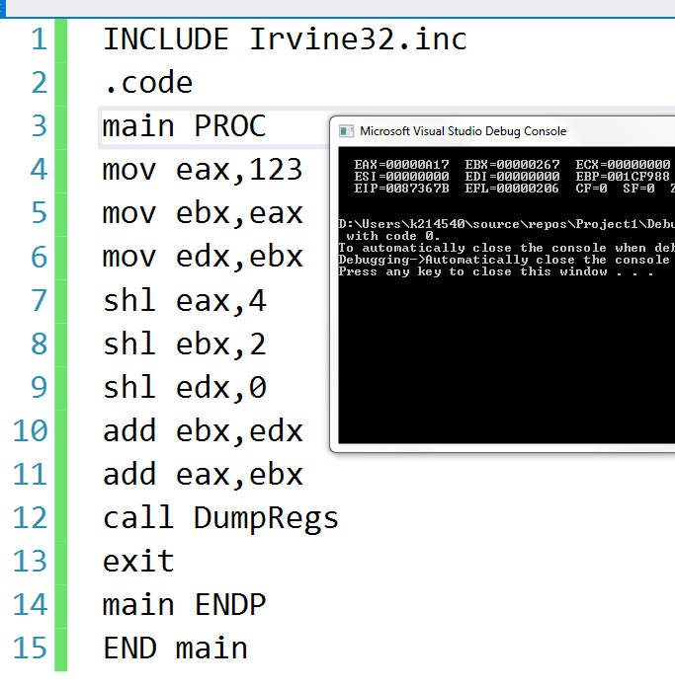

QUESTION NO 2:

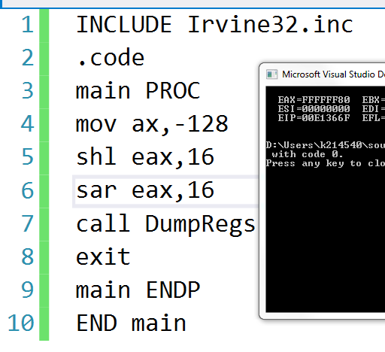

QUESTION NO 3:

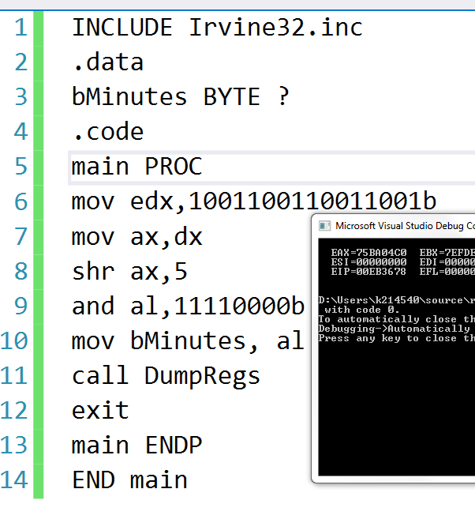

QUESTION NO 4:

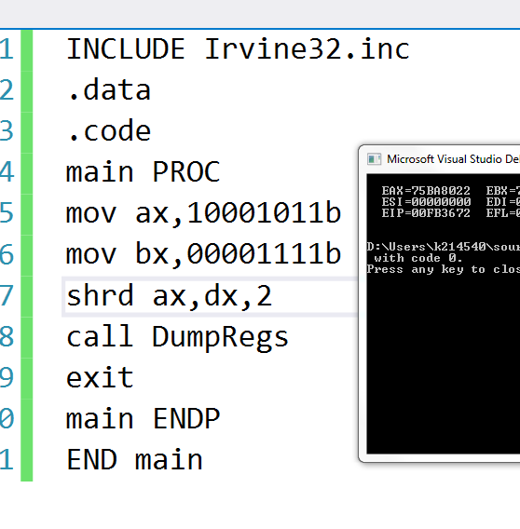

QUESTION NO 5:

